**Assignment 1.1**

Q) Install Jupyter notebook and run the first program and share the screenshot of the output.

**Jupyter Notebook Installation Screenshot :**

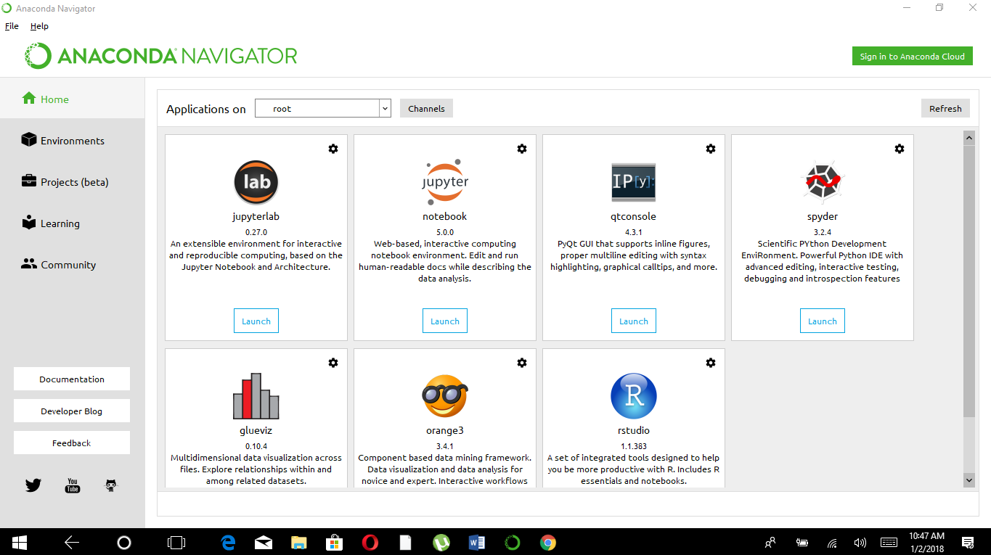

**1st Prog:**

**Code:** # 1.1 assignment

# any thing after doing Juptyer Notebook installation

a=10

b=9

sum=a+b

print("sum of two value is: ",sum)

**O/P:** sum of two value is: 19

